Riphah International University

Gulberg greens Campus

Submitted by : Mahnoor Ahmed
Sap id : 80207
Submitted to : Mam Nayab Khalid
Lab # 08

Task no.1
Hospital Appointments (Overloading)
At City Care Hospital, patients book appointments in three ways: by name only (a general doctor, today), by name and doctor (today), or by name, doctor and day number. Create a class Hospital and overload the book) method three times to handle these cases. Each version should print a confirmation message. Test all three versions in main).

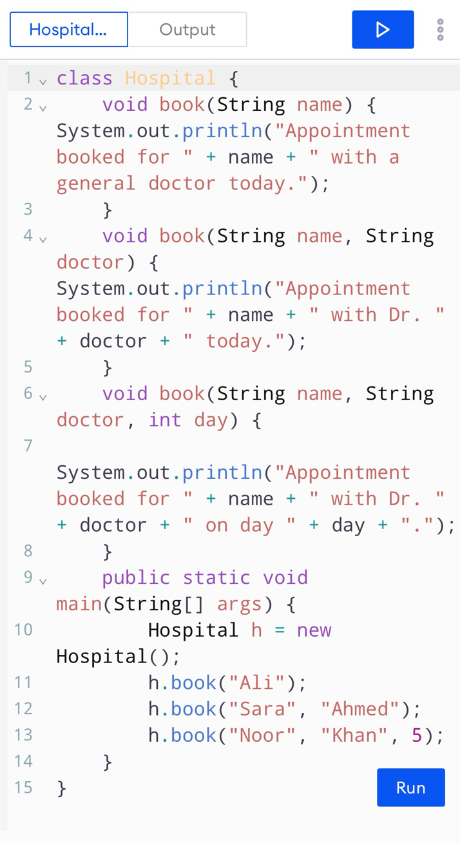
Code:
Result:
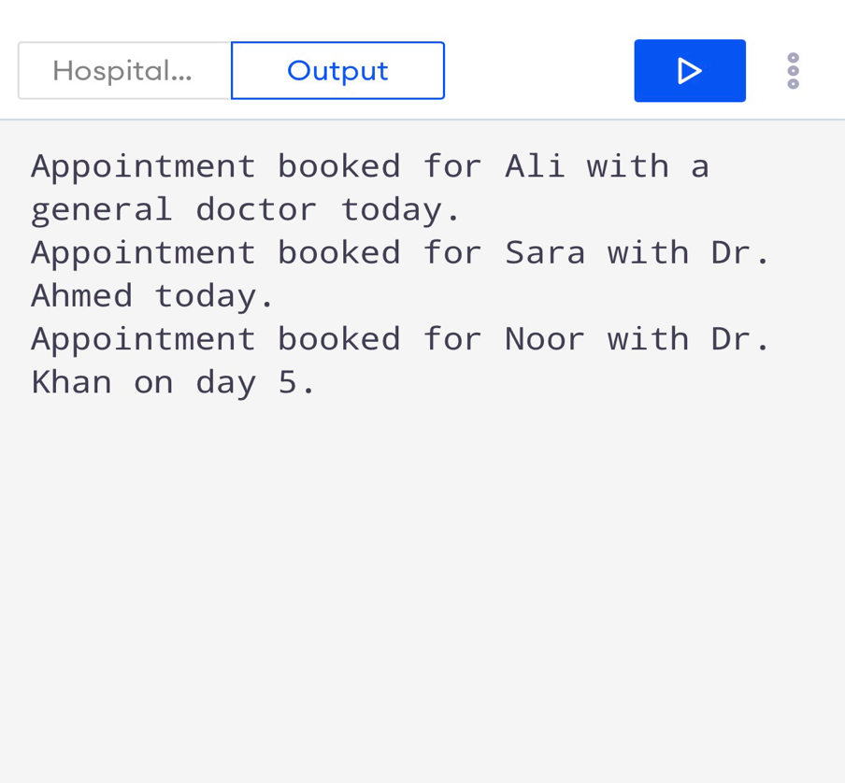

Task no.2
Ride Fare Calculator (Overriding)
A ride app charges a different rate per kilometre for each vehicle. Create a base class Ride with a method calculateFare(int km) that charges 25 per km. Then create subclasses Bike (20 per km), Car (40 per km) and Rickshaw (30 per km), each overriding the method and returning the fare as a double. In main, store all three in a Ride[] array, loop through it, and print each fare for 10 km.

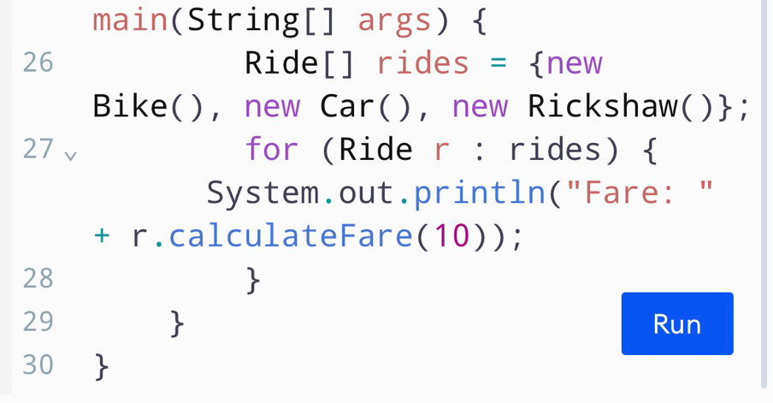
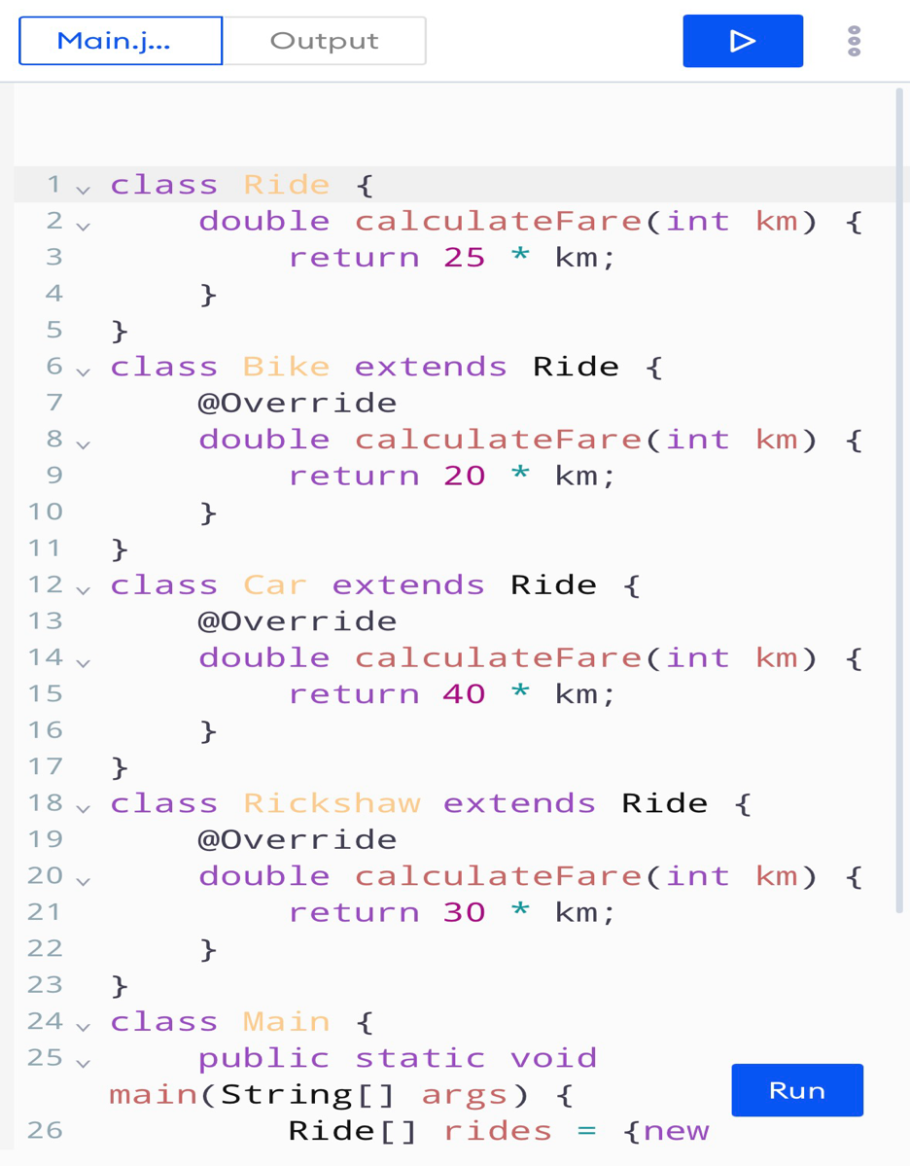
Code:

Output:
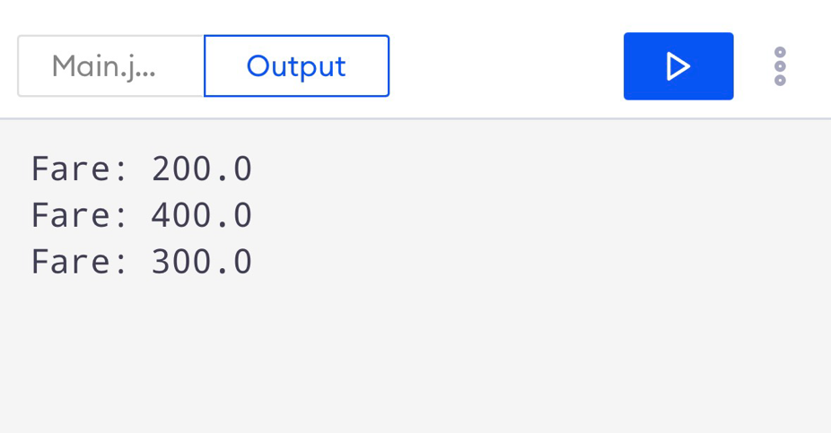

Task no.3

A university calculates student fees with or without a custom discount percentage. Create a class Fee with two overloaded methods: calculate(double tuition) returns the tuition unchanged, and calculate(double tuition, double percent) returns the tuition minus that percentage. Scholarship students get 20% off by default, so create a subclass ScholarshipFee that overrides only the one-parameter method. In main), use a tuition of 50000 and test both classes with both methods.

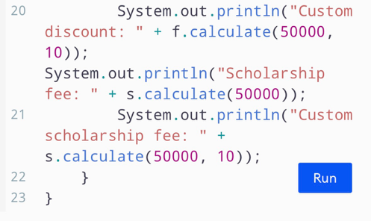
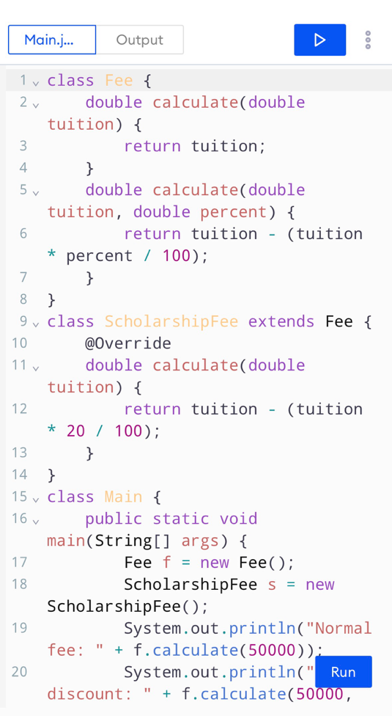
Code:

Output:


